Typographic Portraits

Your Mission: Create four (4) typographic portraits portraying your name as described by a given word.

Materials: Adobe Illustrator

Tools: Create outlines, text, gradient, direct selection, add anchor point, subtract anchor point, convert anchor point, rotate, reflect

Vocabulary: x-height, baseline, midline, ascender, descender, sans serif, serif, script, text, specialty, kerning, leading, baseline shift, dingbat

Steps:
- What is text? What are the different kinds of text?
- What are the different components of text and the five categories of text?
- Watch and discuss PowerPoint presentation on typography.
Lets learn some new tools that involve text!

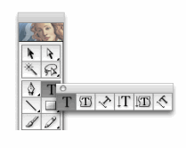
Text Tool ( T )
This tool lets you enter type at a point, in a
type area, or on a path.
- To Enter Type at a point:
- Select the type tool, the pointer changes to an I-beam within a dotted box.
- Click where you want the line of type to begin
- Enter the desired text. Press enter or return to begin a new line of text within the same type object
- To enter type within an area:
- Select the type tool
- Define the bounding area: drag diagonally to define the rectangular bounding area
- Enter the desired text
- To enter type on a path:
- Select the type tool
- Position the pointer on the path and click
- Enter the desired text.

- 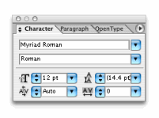
Changing Text Size and Font
- Window>Type>Character (ctrl+ T) This will bring up the Character Box.
- This box you can change the font, size, leading & kerning
- Create Outlines: making the text into a shape
- Type>Create Outlines
- This lets you manipulate the text using the selection tool, add anchor point, delete anchor point and convert anchor point, just like the squares in the square designs
- 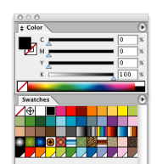

- Changing Colors
- Window>Swatches or Window>Color
These two menus allow you to change the color to the text and to the outline of the text.
You may select a color from the swatches or you may create your own color from the color menu

- Adding a Gradient
- Window>Gradient
- There are two types of gradients: radial and linear
- This allows you use multiple colors and to gradually move from one color to another.
- 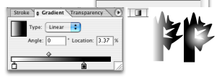

- Practice: using the word “campfire” create outlines and manipulate the text so that it looks like a campfire.
- Brainstorm: list of words
- Choose two words that you want to illustrate with text
- Research on the internet the definition of your word and find 3 images for each one, that you think represent your words.
- Write up what you have found in a Word document.
- 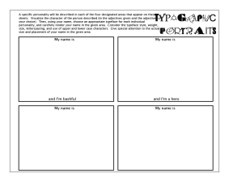
Using what we just learned about text create four (4) typographic portraits using your own name.
- Use the 4 words you chose and researched for your second two.
- First choose a font that represents your word
- Next create outlines
- Manipulate your text to look like your word
- Add color or a gradient to help your text look like your adjective.
- Things to think about:
- Placement in rectangle: Are you going to put your text in one corner of the page or on the bottom half of the page?
- Size of text: Does your adjective call for a LARGE BOLD font that takes up the whole page or a small narrow font? Think about composition.
- Color: What color(s) best represent your word?
- Rotate Text
- Shape adjustments and additions: What do you need to add or change to make your text look like your word?

